**Task-1**

# Download the Dataset:

## Churn_Modelling.csv

**Task-2:**

# Load the Dataset:

Solution:

import numpy as np import pandas as pd

import matplotlib.pyplot as plt import seaborn as sns

import matplotlib as rcParams

df=pd.read_csv('Churn_Modelling.csv') df.head()

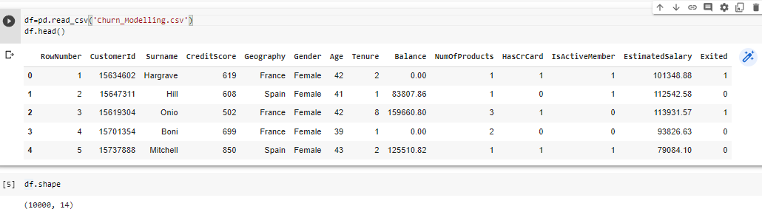

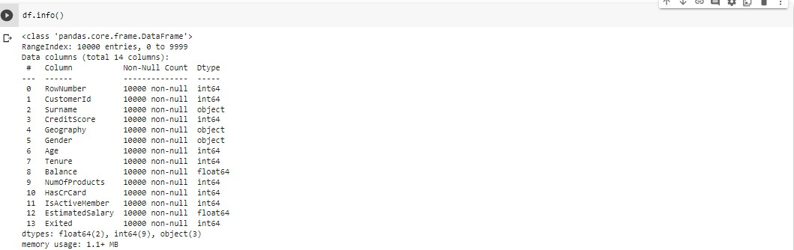

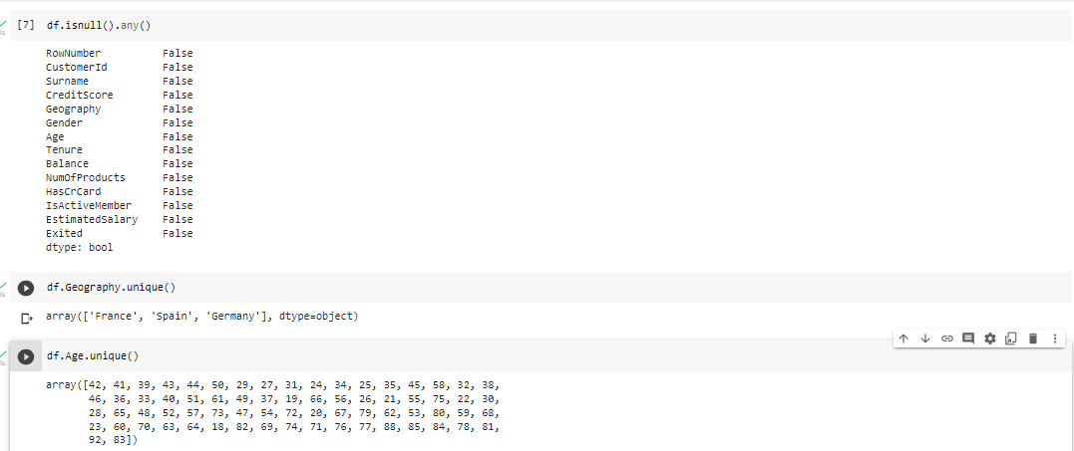

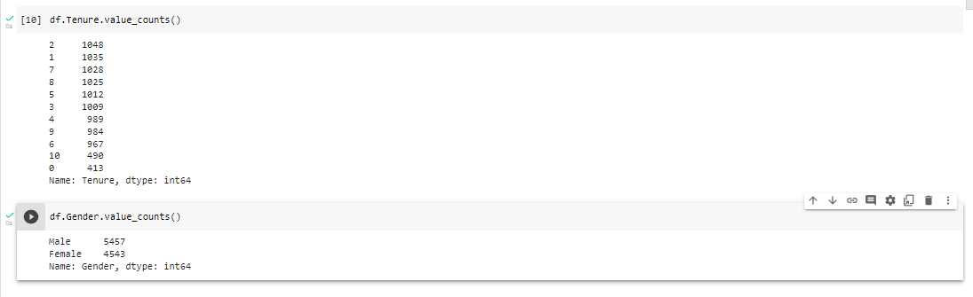

**Task-3:**

# Perform Below Visualizations.

* + Univariate Analysis
  + Bi - Variate Analysis
  + Multi - Variate Analysis

## Univaíiate Analysis:

SOLUTION:

sns.displot(df.CreditScore)

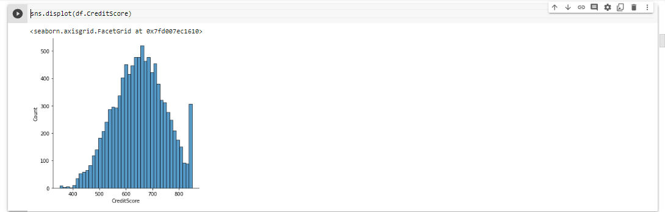

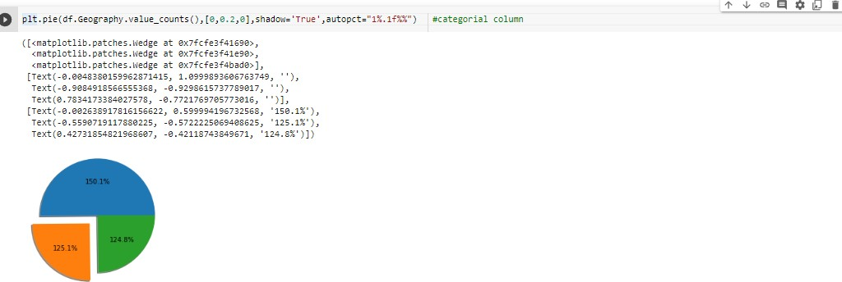plt.pie(df.Geography.value_counts(),[0,0.2,0],shadow='True',autopct="1%.1f%%") #categ orial column

sns.stripplot(df.Age,color='Green')

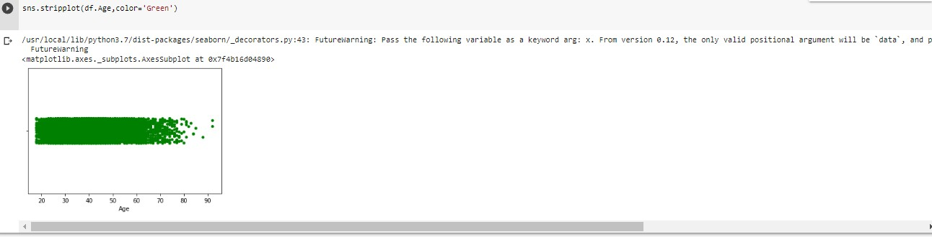

sns.ecdfplot(df.Balance)

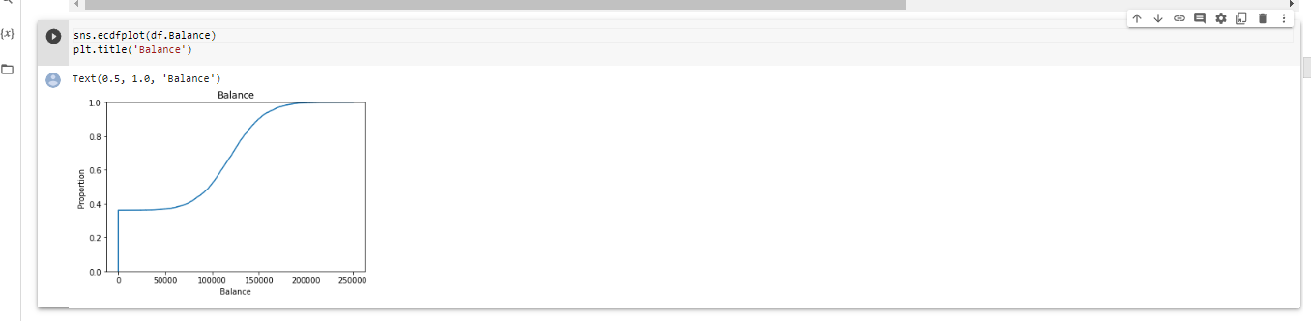

## Bi-vaíiate Analysis:

SOLUTION**:**

plt.bar(df.Age,df.EstimatedSalary,color='Red')

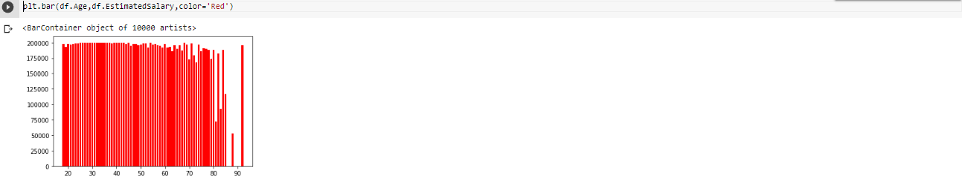

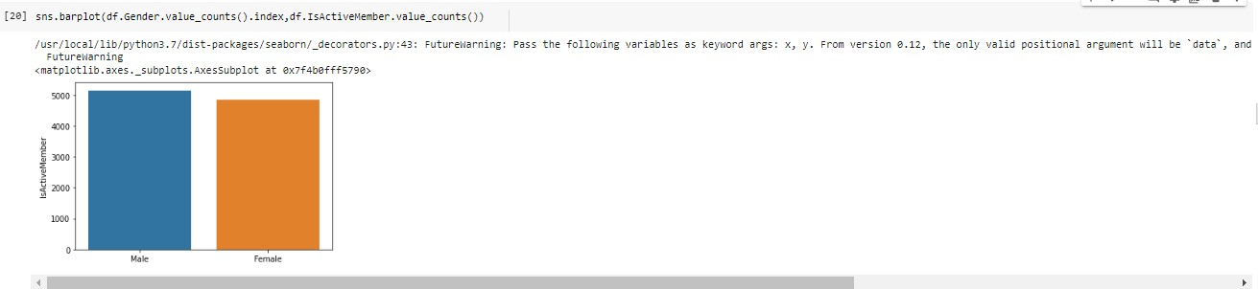

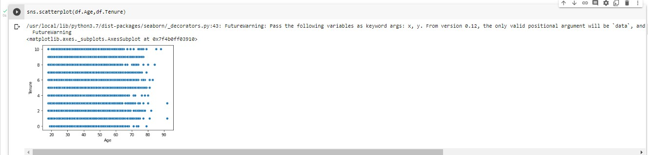

**Multi-Variate Analysis:**

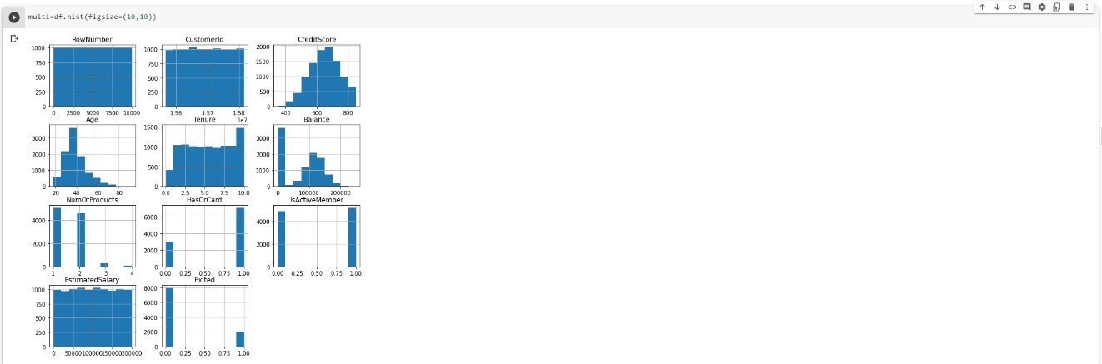

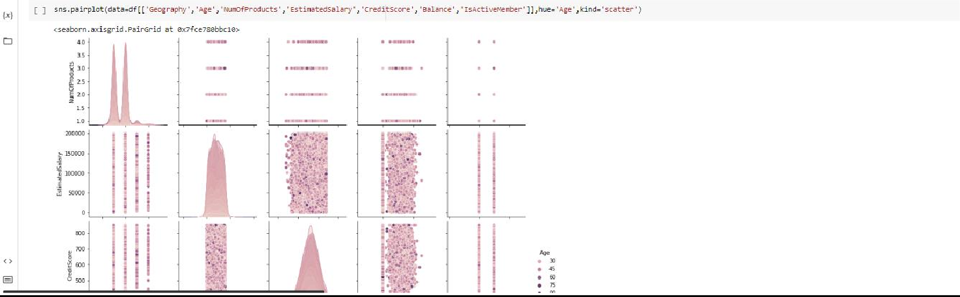

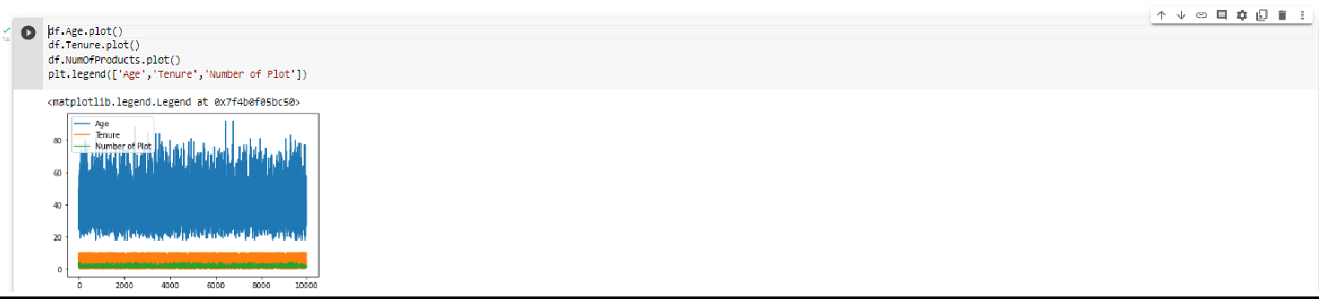

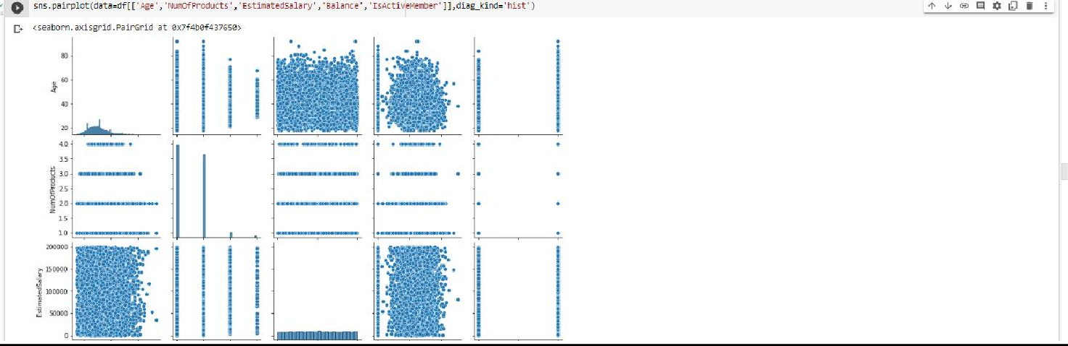

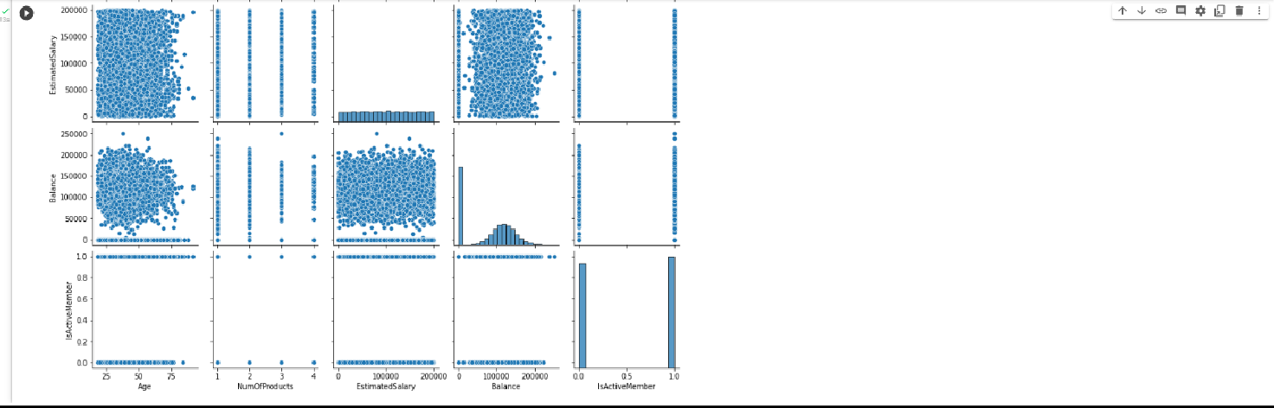

**Task-4:**

**Descriptive Statistic**

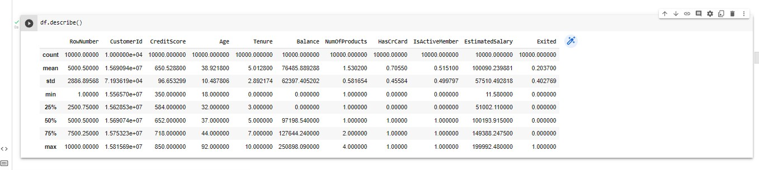

**Task-5:**

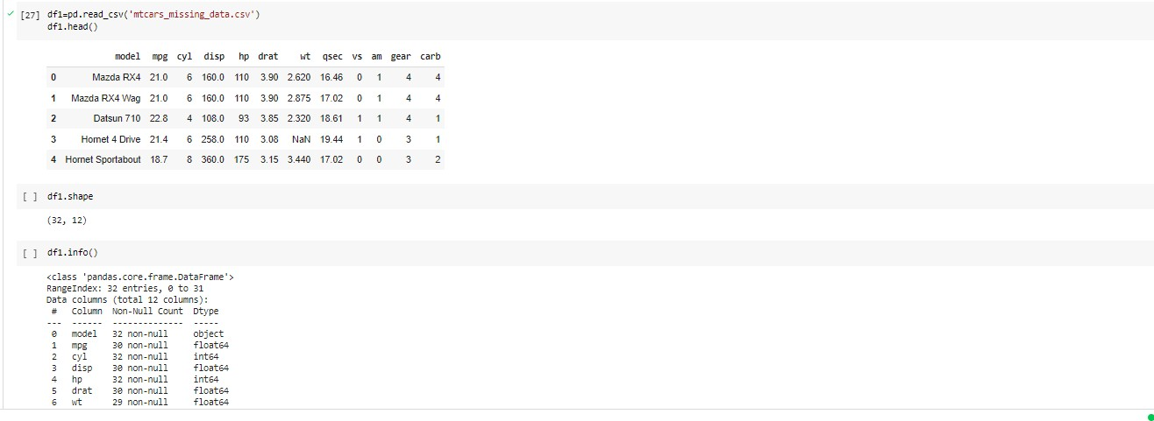**Handle the Missing Data:**

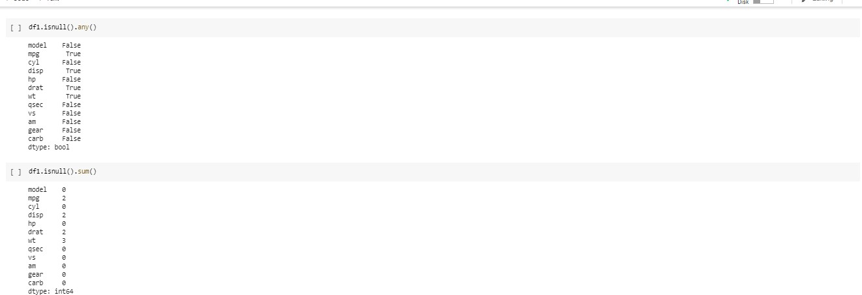

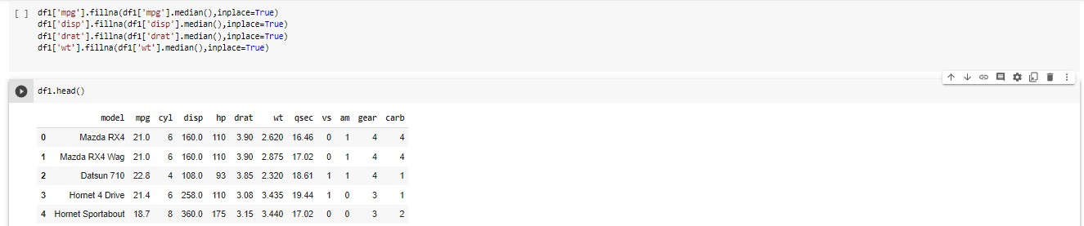

**Task-6:**

**Outliers Replacement:**

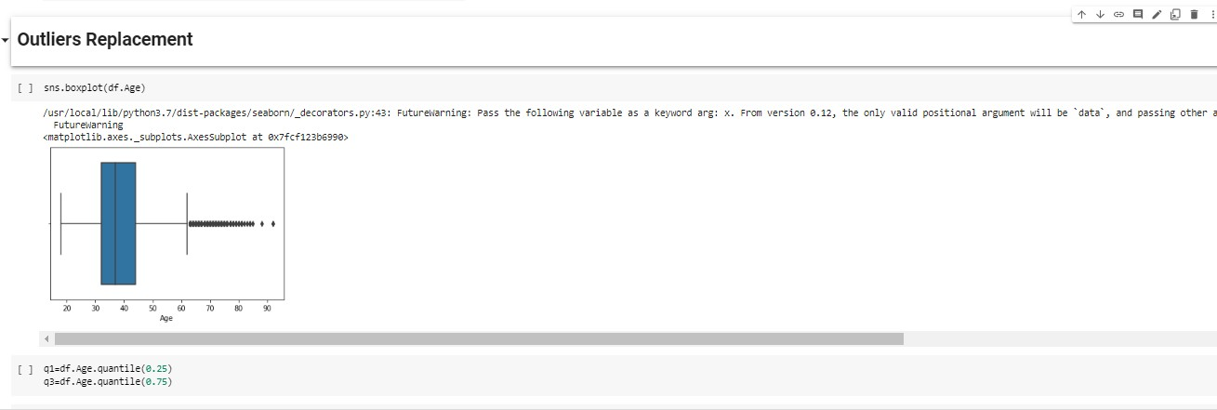

IQR = q3-q1

upper_limit=q3 + 1.5 * IQR

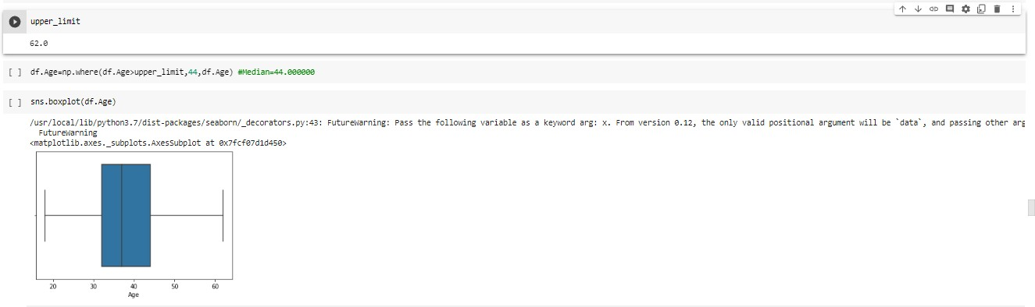

**Task-7:**

**Check for Categorical column and perform encoding:**

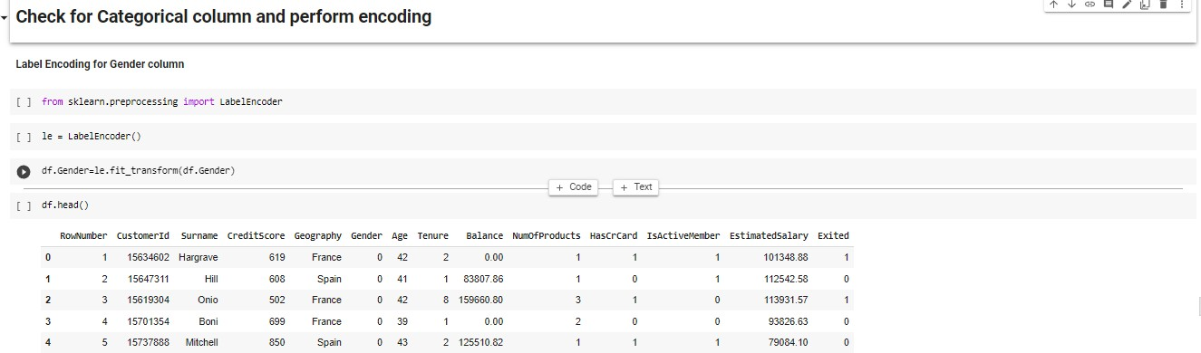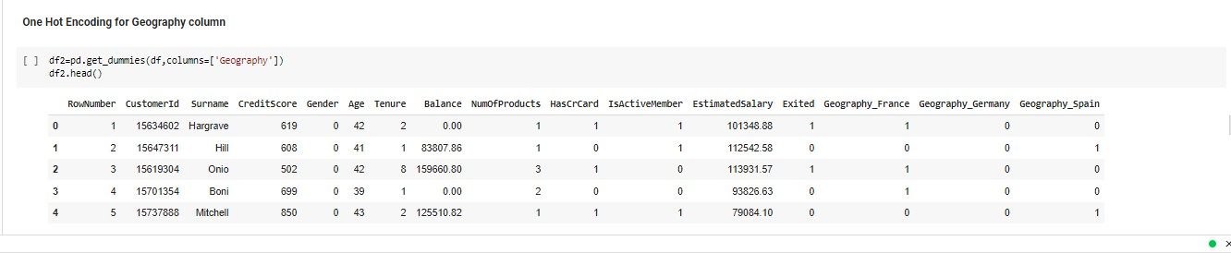

**Task-7: Correlation:**

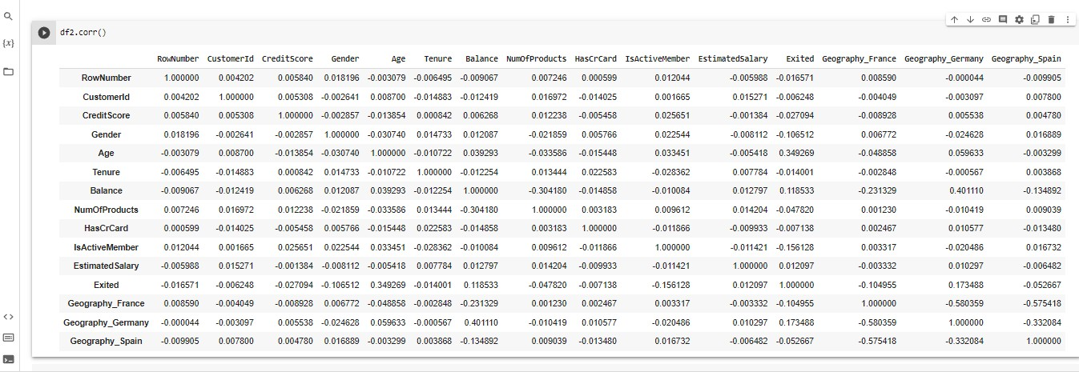

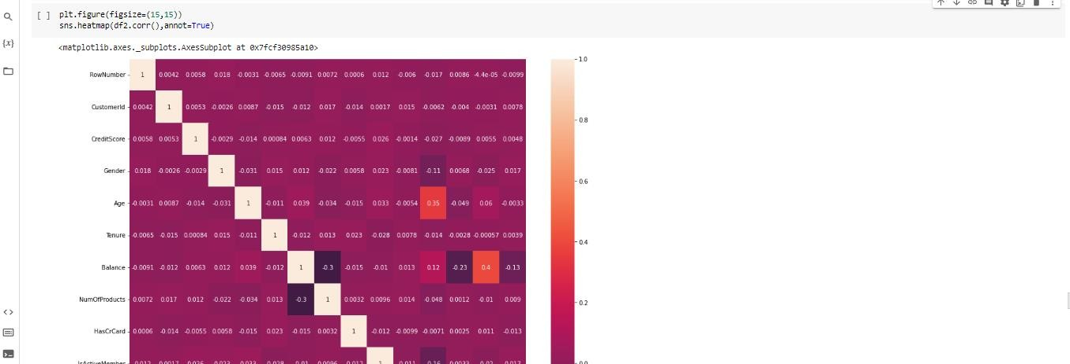

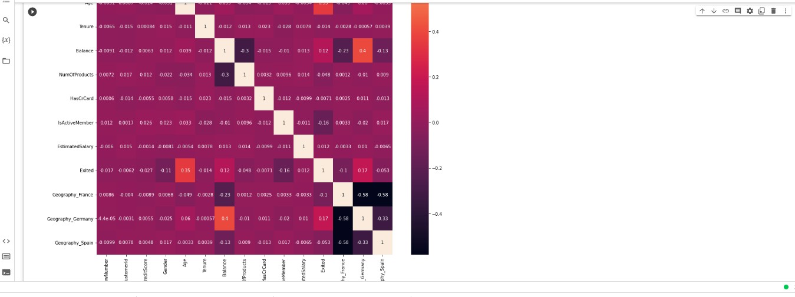

**Task-8**

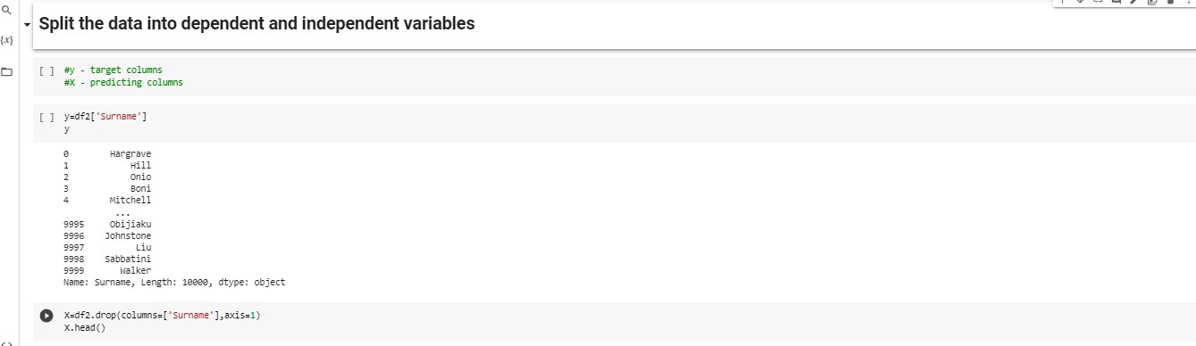**Split the data into dependent and independent variables:**

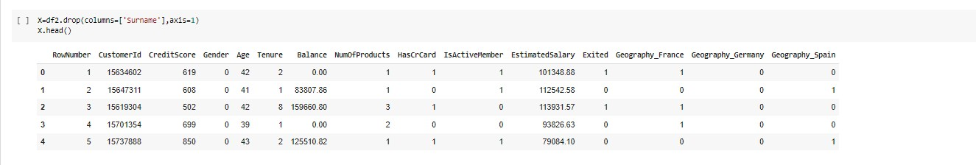

**Task-9:**

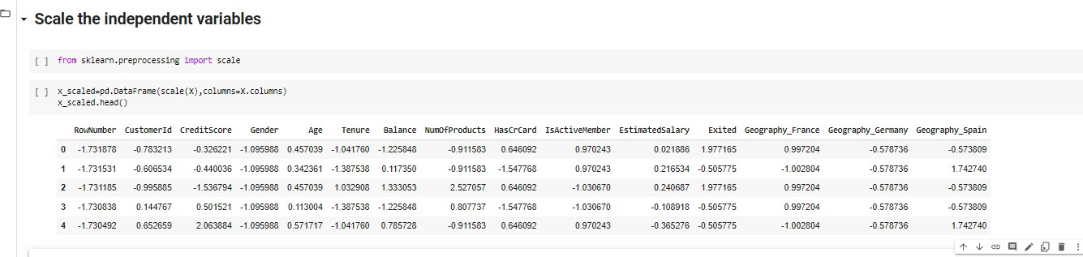**Scale the independent variables:**

**Task-10:**

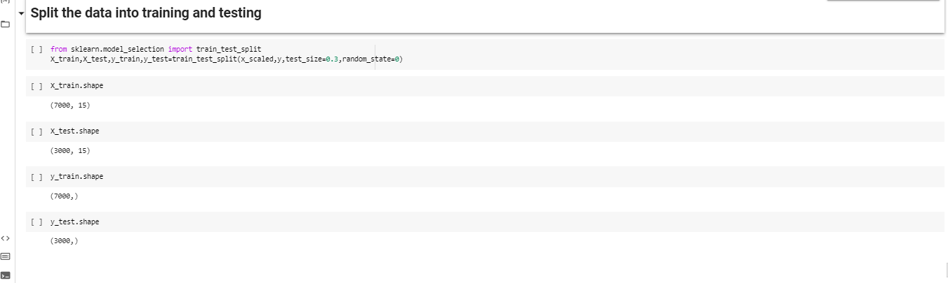**Split the data into training and testing:**